[[Gregor Rosenauer]]

Motivation and Vision Statement
- Although the idea behind personal knowledge graphs dates back to the 1960s with the now famous Zettelkasten method by Luhmann (Schmidt, 2018), it only became popular in recent years with the introduction of connected note-taking tools like Evernote, Notion, Roam (and its open source cousin Foam (foambubble, 2022)) or Obdisian, to name only a few.
- On the other hand, there is also valid criticism in the usefulness of this approach (see chapter 9 in this book on “A decentralised social network of Solid-based second brains” by Mathew Lowry), as a graph does not make one any wiser per se, and connections alone do not bring much new insights beyond the fact that the linked information is connected somehow. Also, current systems of this kind only use tagging, which is the simplest form of classification, but does not hold any deeper semantics to allow meaningful identification of entities and their properties and relations. Without an additional classification on how and why some bits of information are connected, users cannot gather meaningful output, as they cannot navigate and query based on the depth of knowledge they gathered, confined to see only on shallow, labelled connections on the surface.
- Also, not everything can or should be captured in note-taking applications and handled via cloud services, as sophisticated as they may have become.
  - these services limit what users can do with their data, and without the service, which is bound to a single vendor, the data mey become inaccessible or unusable, at least connections and navigation are then lost.
  - cloud providers either charge recurring fees or utilize user data, which can even pose a threat to users in unsafe environments (like journalism or activism), and is not suitable for sensitive or business data (possible infringement of intellectual property, transfer of copyright to the provider, etc.).
- A lot of valuable information is still locally stored on personal desktop systems in the form of carefully selected documents, ebooks, papers or other media, possibly restricted or private sources, and personal artifacts like project notes, ideas, concepts, or drafts.
- personal knowledge graphs should also cover all kinds of information, not only document or media entities, but also various communication (mails), contacts and events (conferences, meetings, etc.) already present in the user’s environment, and highly connected to personal data and work that derives from it.
- A truly personal knowledge graph needs to live “on the edge”, i.e. the user’s system, it needs to embrace that existing information, understand its connections, make them visible to the user and allow to navigate and query it.

A Vision for a Personal Knowledge Graph based on the Semantic Desktop
Wise up your Workspace - Why a Personal Knowledge Graph should live in your personal desktop system
- The most natural and feasible way to implement such a system would be to utilize a modern OS that provides a semantic filesystem, with attributes and relations built-in.
- Although many modern filesystems now support custom attributes as key/value pairs (“xattrs” for “extended attributes”), they still don’t allow to query for them, neither in a simple graphical way for end-users, nor even for advanced users using command-line tools such as UNIX find (as an exception, only BSD and hence Darwin/MacOS provide an extended find variant that supports searching extended attribute keys and values using an -xattr and xattrname switch, respectively)
  - for Linux, there is now an open-source tool (Bhihe, 2022/2022) that supports this as well, providing a shell wrapper for the find command with xattr extensions.
- Still, there is no support for semantic relations in any modern desktop system, reducing the use of desktop semantics to static metadata for display in info panels (like a details view in file browsers).
- Instead of implementing query support and native support for relations beyond simple links directly in the filesystem layer, current semantic desktop solutions introduce a separate data storage like embedded SQL databases, adding a lot of overhead and introducing data synchronization issues. They often introduce complex API`s that are more aligned to the semantic web than the desktop, which makes development harder than needed and slows down adoption and user acceptance <<REF!>>.
- More ambitious efforts in file system development failed because of similar complexity, trying to integrate a full-fledged database into a desktop OS intended for everyday use (see “History” section below).
- So an ideal solution should be lightweight and integrate transparently and naturally with the desktop the user knows and operates daily, built on a file system that supports semantic queries or can be extended with minimum overhead.
- SEN (“Semantic ExteNsions”) follows this approach by utilizing and extending the rich infrastructure and API already provided by Haiku, the most prominent open-source descendant of BeOS . Files naturally represent entities, as the type system is based on MIME types, properties of entities are stored in custom filesystem attributes, only relations have been omitted because the original creators of BeOS identified the same fallacies outlined above (the first version of the OS still had a Table and Relations API though).
- SEN circumvents this by also storing relations in file system attributes, similar to properties, and providing a very thin, message-based API to bridge this extension of the base OS.
- For performance, any file that is part of a relation gets a unique and stable identifier (like an Object ID in a document management system or database), and relations reference this ID in a single custom attribute. Because both the Object ID of the source (file) and the relation IDs of the target files are stored in indexed attributes, they can be queried very efficiently.
- Relation properties are stored in additional attributes that need not be indexed, as they are retrieved on demand in near real time. They are stored in separate attributes as a map of relation property key/values for each relation.

How to Build it: The Pillars of the Proposed Solution

Design Philosophy and Core Principles
- simple: KISS, SEN is not an expert system, but targeted at personal desktop and average users: should gradually and transparently provide more advanced functionality as needed and understood
- unobtrusive: should not impact system performance and resources notably
- transparent: should integrate with desktop and common metaphors, working directly on files, folders, filetypes and attributes - extensions to desktop (file manager, behavior) only where needed (e.g., to integrate new concept of relations)
- open but private: system should be open for extension, but personal data is kept private and does not leave the personal system: extension through plugins (e.g., for extracting attributes and entities from files), for importing data (e.g., ontologies or individual entities from schema.org), and for exchanging data where explicitly requested (linked data between users).

Learning from the Past: A short history of promises and failures of the Semantic Desktop
- (Sauermann et al., 2009) introduced an innovative concept for a semantic desktop and semantic applications, or even just simple extensions and mashups, enriching existing applications (a concept shared by SEN). It was realized as part of the KDE Linux desktop in the form of NEPOMUK (Bernardi et al., 2011), an ambitious EU funded research project.
  - Over the course of the project lifetime, however, it quickly became a problem to use a full-fledged database and full-blown standards like RDF even for simple files and metadata, and so a new generation of KDE search was realized (KDE’s Next Generation Semantic Search, 2014): > Instead of having a single RDF-based database for all information, Semantic Search now provides separate data stores > and search interfaces. This allows it to store and search each type of content in an optimal way.
  - The latest incarnation follows a more lightweight and flexible architecture and uses a file indexing and search framework called “Baloo” (Baloo - KDE Community Wiki, 2022) “with a focus on providing a very small memory footprint along with extremely fast searching.”, indicating and fixing one of the major obstacles of semantic desktop adoption of previous efforts.
- Similar approaches were also tried in mainstream OS’s but failed, e.g., Microsoft’s WinFS (LSoft Technologies Inc., 2022) - see also a critical but insightful discussion in (Orlowski, 2002) by the developers of the more successful and actually fully realised BeOS File System BFS, which is detailed in the next section.
- To summarize, problems with current solutions can be roughly divided into the following categories:
  - Falling into the Complexity Trap: requiring users to categorise and connect all their data by hand, or applying the fulls set of semantic web standards to the desktop: many projects failed because they tried to build the entire complexity of the semantic web for personal knowledge graphs, which is not really feasible or sustainable, see e.g. Gnowsys (Nagarjuna, 2013) for an ambitious project that wanted to build a “A Kernel for Semantic Computing”, but is dormant since 2013.
  - Leaky Abstractions: by exposing the full breadth of semantic (web) standards and concepts, and requiring familiarity with them, including SPARQL for search, or RDF for storage and manipulation, implicitly targeting expert users and neglecting usability and graphical support, everyday users are left behind, severely hindering widespread adoption and thus market adoption and in turn developer support, which would be needed to extend and integrate applications.
  - Neglecting the Performance Impact: as outlined above, previous semantic desktop efforts failed because the resource impact caused by indexing and metadata extraction was simply too high and not deemed worth the effort by many users, because of the other problems mentioned here.
  - Missing Query and Navigation Support: semantic desktop solutions should provide additional benefit beyond simple metadata storage to be really useful and accepted by end users. Explicit and implicit relations should be navigable and exposed throughout the system, including supported applications, and powerful search on semantically linked data should be supported in a simple and intuitive way.

BeOS - The First Semantic Desktop OS
- history (Pinheiro, 2020)
- Entities, not Files
- Universal Interoperability through Custom Attributes - no specialised applications needed for simple CRUD operations
- Metadata Queries
- already very advanced user-centric, worked well in everyday use, but failed to gain enough traction to survive
- rather unknown niche OS, but closest to the “GraphOS” outlined in (Alexander Obenauer, 2021), which proposes an “entity-first” operating system with related concepts: > In the Graph OS, all of your things are within your system as nodes, or items, within your graph. Emails, calendar events, > articles, web pages, podcast episodes, to do lists as well as the to dos inside them; everything. And each thing may have > references to, or be referenced by, any other thing.

Introducing SEN - a modern minimalist user-centric approach
- BeOS already supported a lot of use cases for a semantic desktop, as can be seen in the workshop provided in Humdinger, B. (2019)
- However, to keep the system and API design simple and efficient, a necessity in the time of its making (late 1990s), the concept of relations was deliberately omitted completely.

Haiku - the Perfect Prototyping Environment
- short description with references
- A good introduction to Haiku OS and its still innovative concepts utilised by SEN can be found in (Revol, 2017).
- (Google, 2007) provides an insightful presentation with the Ex-CEO of Be, Inc., who created BeOS, the original commercial OS created in 1996 after which Haiku is modelled.
- components used by SEN:
  - Tracker
  - FileTypes
  - Filesystem API
- mapping SEN concepts
  - File types
  - Attributes
  - Queries
- picks up concepts from BeOS for filesystem based metadata handling and search

Basic Architecture
- system daemon and core implementation for interacting with file system, integrating with existing OS components, API’s and applications like the file browser “Tracker” and the desktop search “Query” application: 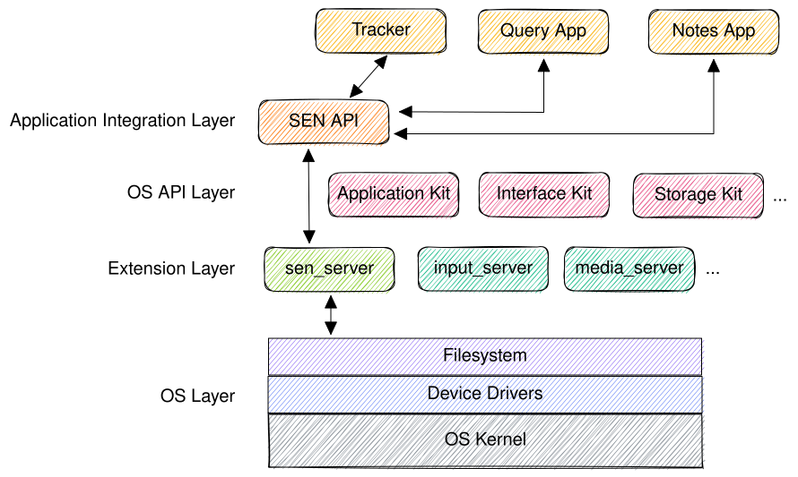
- thin message-based API for integrating with applications including the standard file browser (called “Tracker” in Haiku)

Relations - the missing Link
- corner stone of the proposed solution, storing relations between files, along with relation properties, in filesystem attributes:
  - SEN_ID: a unique ID (like an Object ID in document storage systems), simplified as small numbers below, but is really a UUID (dashes could be omitted for compactness).
  - SEN_REL_TARGETS: comma-separated SEN_ID’s of referenced files
  - SEN_REL:\<ID>:\<LABEL>: properties of relation with label ‘LABEL’ to target with SEN_ID ‘ID’ as a key/value map (‘BMessage’ type in Haiku)

Queries - resolving relations
- Haiku natively supports queries on standard and custom filesystem attributes, so relation targets can be resolved by simply querying for files with a SEN_REL_TARGETS attribute that contains the SEN_ID of the relation source.
  - e.g. for resolving all relations of type contributesTo of a file entity with SEN_ID of 0815, the SEN server executes a native filesystem query using the Haiku filesystem API to find all files with a SEN_REL_TARGETS attribute containing the String 0815, where multiple targets are simply comma-separated.
- There is also a simple Query UI that allows users to enter queries through a search field and specify various options to narrow down the query.
- For better performance, attributes need to be indexed, so they can be found through queries.
  - SEN only indices the SEN_ID and SEN_TARGETS field, but not attributes holding relation properties, to not blow up the filesystem index more than absolutely necessary.
  - This means that querying for relation properties is not directly supported by using filesystem queries (which will only return matching relation targets regardless of their properties), but can be provided by the SEN API, filtering property attributes of relation targets returned by the native query. While this introduces a slight performance impact, it is an acceptable and deliberate compromise, as this is not a primary use case and should still be sufficiently fast for a fluid user experience (which is ensured by using an efficient naming scheme and structure for attribute values, as detailed below).

Mapping the conceptual model of SEN to OS and desktop concepts
- SEN realizes a simple form of ontologies through only using file system semantics and the OS filesystem API, adding support for configuration, management and navigation of relations with a custom API on top.
- Ontologies in SEN are comprised of:
  - Entities and their attributes are defined through file types and their properties
    - Configuration is already handled through a well-defined OS file attribute BEOS:TYPE and a user-facing settings application
    - The OS natively uses standard MIME types (MIME Types (IANA Media Types), 2022) for identifying the file types, as described in Humdinger, B. (2009b).
    - File name extensions as used in other operating systems are purely optional in Haiku, as the OS uses a MIME database and checks the file’s type attribute for a match.
    - The file type is detected by inspecting the file itself, using MIME type sniffing, e.g. parsing magic byes. Extensions are only a fallback, if all else fails.
    - File attributes map to our Entity properties, see Humdinger, B. (2009a) for details and illustrations on how this is realised in Haiku.
    - (Melnikov, 2022) defines all officially registered MIME types, which provide a wide variety of media types (and hence entity classes), but for desktop use, custom entity types can be defined as valid MIME types using the application/vnd. namespace.
  - Relations and their properties are not natively supported, so SEN uses a separate configuration to manage relations and links them to Entities by storing MIME-types for relation source and target entities, as well as default relation properties (custom properties could be added to the configuration or even individual relations, but users should be encouraged to adhere to standard properties for ease of use and consistency).
  - a formal Schema is deliberately not endorsed to keep the system practical and approachable for non-expert users, who might not be familiar with semantic concepts. SEN tries to lower the barrier to entry and bring semantics to the average desktop user. However, Relations and FileTypes may be defined by more advanced users and even bundled with SEN, sot hat reuse, exchange and interoperability is maximized. E.g., as mentioned above, file types should use standard MIME types, and file attributes used for properties, as well as relation names and attributes, should stick to established standards like (schema.org, 2022) or Wikidata (Wikidata, 2019), including their syntax and semantics, as far as possible, so they can be interpreted in a common way by plugins (such as Extractors XXX, which can then use common attribute names to store extracted information, which can then be easily picked up by other SEN services or applications), and RelationHelpers, which can then rely on common attributes for navigation and highlighting.
  - E.g., Book should be used as a reference for Book entities in SEN. The well-defined attribute keywords can then be used by Extractor plugins to store tags and keywords extracted from documents, and the standard startOffset attribute is used for navigating to a specific position.
  - Schema.org defines a set of standard properties that SEN tries to adhere to.
- for internal use, but also for interaction with desktop applications, SEN provides an API to filter suitable relations based on the source file type and relation configuration.
- Applications use this API to provide a way for users to specify meaningful relations on files, and to display relations in a meaningful way.
  - e.g., an extended version of Tracker uses the SEN API to resolve relations for a particular file and display them, along with their properties, in a menu or separate window.
  - an extended text editor may use the SEN API to query for related content and references
    - e.g., self-references (like sections in a chapter or methods in source code)
    - references to other text files, people, locations, concepts or media sources (like books, movies, or songs).

Example PKG: Books, Authors and Publishers
- simple graph from 3 entities: Book, Author and Publisher
- the Author writes a Book that is published by a Publisher who pays the Author.
- details about the relations (like date of publication, or amount of payment) are modelled as relationship attributes.
- relation properties are stored in file attributes, prepended by the target ID, because properties are unique to a specific relation.
  - the naming scheme used, SEN_REL:<target ID>:relation name) allows for easy and fast detection of SEN relation properties
  - properties themselves are stored as key/value pairs (using a BMessage, which is basically a hash map, and which can be stored in and retrieved from file system attribute values by the native API, see (Haiku, 2022))
  - if a relation to a particular target has multiple properties of the same name, e.g. references to several locations in the same book, they are grouped and stored as a list, which is also supported natively by BMessage objects.
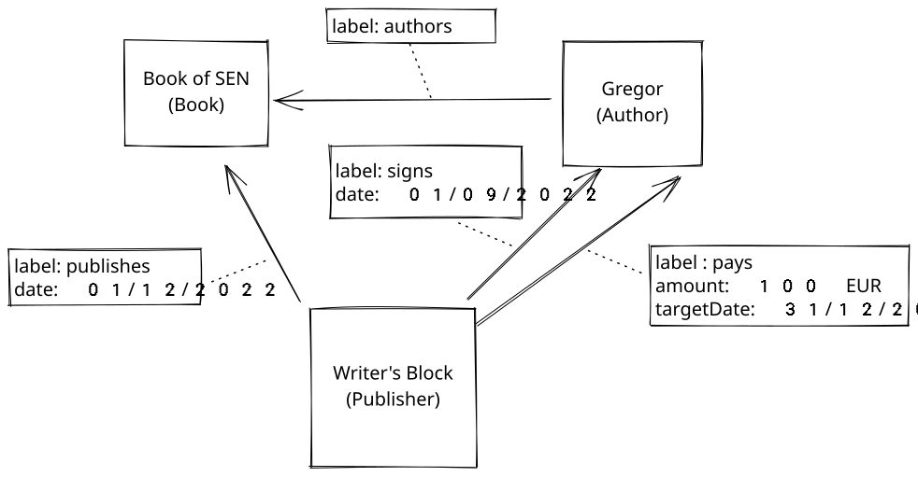
Book Graph
- In this example, a book chapter is stored in a file named “Book of SEN.md”.
- The file is of type text file with MIME-type text/markdown, which represents a Note entity.
- For this file type, SEN has registered a relation authoredBy with property role:
BEOS:TYPE | SEN_ID | SEN_REL_TARGETS | SEN_REL:0815:authoredBy | SEN_REL:4711:publishedBy | (standard file attributes)…
text/markdown | 123 | 0815,4711 | role:author | role:publisher
- File “Gregor Rosenauer” of type application/x-person, which denotes a Person (this is actually not a registered MIME Type but used by the OS, however SEN could define an alias to be used, which may also contain more attributes of a Person)
BEOS:TYPE | SEN_ID | SEN_REL_TARGETS | SEN_REL:123:authors | (standard file attributes)…
application/x-person | 0815 | 123 | role:author
- File “Writer’s Block” of type application/x-person, which acts as a placeholder for an Organisation here (for simplicity only, as there is no official MIME Type for Organisation, but since the semantics are slightly different, e.g. in terms of employment relations, a separate type should be defined here):
BEOS:TYPE | SEN_ID | SEN_REL_TARGETS | SEN_REL:123:publishes | (standard file attributes)…
application/x-person | 4711 | 123 | role:publisher,date:01/12/2022

BEOS:TYPE | SEN_ID | SEN_REL_TARGETS | SEN_REL:123:signs | SEN_REL:123:pays | (standard file attributes)…
application/x-person | 4711 | 0815 | date:31/12/2022 | amount:100 EUR,targetDate:31/12/2022

Example: Notes and Annotations
- This example uses Note entities referencing textual notes and related annotations:
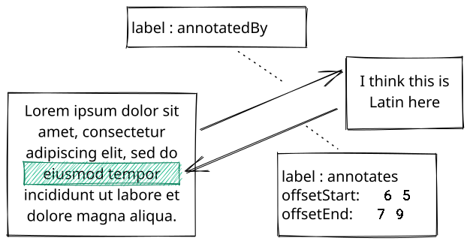
Notes Graph
- File “Lorem ipsum.txt” of type text/markdown (representing a Note entity):
BEOS:TYPE | SEN_ID | SEN_REL_TARGETS | SEN_REL:2412:annotatedBy | (standard file attributes)…
text/markdown | 1130 | 2412
- File “Annotation.txt” of type text/markdown (also a Note entity) references a particular passage of text in the file above
- the text range is provided as relationship attributes offsetStart and offsetEnd
BEOS:TYPE | SEN_ID | SEN_REL_TARGETS | SEN_REL:1130:annotates | (standard file attributes)…
text/markdown | 2412 | 1130 | offsetStart:65,offsetEnd:79

Ternary Relations
- A special case but also an important use case is the support for ternary relations, that is when 3 entities are part of a relation.
- An example would be, extending the notes example above, relations between notes on a movie referencing actors that appear in certain scenes, or locations on specific time codes:
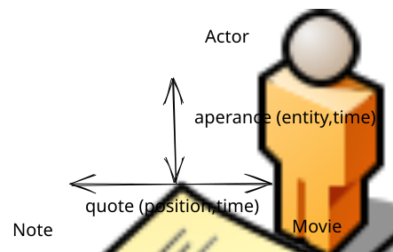
Ternary Relations
- To cover this case, and staying consistent with the “relationships as properties” concept established above, we can store references to other entities along with normal relationship properties, but with special semantics, e.g. using a reserved label SEN_ID as property key, and the ID of the target entity as property value.
- For differentiating properties of ternary relations, however, one more abstraction is required, so we need to wrap them into separate, nested BMessage objects inside the BMessage holding our normal properties, as outlined above.
- This would also cover the case of having multiple references to a single entity with different properties, e.g. the same actor in different scenes, or the same location at different time codes.

Desktop Use Cases and Examples - Re-modelling standard applications with SEN

Base Concepts
- Files as Entities
- Relations grouped by role (Attendee, Contributor) or relation label (attendedBy, contributedBy)
- UI: in Haiku (as in BeOS), it is a common desktop metaphor to have clickable menus, e.g. clicking on a folder item in the “Copy” menu will open that folder in a new window.
  - The same metaphor is used for navigating relations: clicking on a sub menu in the “Open Related…” menu will open all targets of that relation in a separate window:

Visualising and Navigating Relations in Tracker
- Because SEN is very user-centric and should not be limited to experts and knowledge workers, the standard file browser, Tracker, is extended (with minimal modifications) so that relations are visible in the context menu, and users can open related files just as they would with normal files, but with some added functionality to support semantic relations.
- A special case is the display of all related files for a given relation - here, SEN uses a special “virtual” folder (similar to dynamic queries !!ref) to hold relation targets:
  - Since also menus (holding sub menus) can be invoked in Haiku, users are accustomed to this behavior.
  - When invoking a “related entities” menu, the adapted Tracker calls the SEN API to create and return a reference to a special, temporary folder holding all targets of the selected relation.
  - These targets are symbolic links acting as placeholders for the related files. SEN stores relation properties as filesystem attributes in these links.
  - The folder is configured to show all relation property attributes, so that the user can view and handle them just like normal file properties, rearranging and sorting them as needed.
  - relation properties may be in any format that is best suited for the purpose, from different data types (names, numbers or dates) to individual representations like JSON-LD for WebAnnotations (attached to web links) or time codes for referencing a specific section in a video.
  - these semantically enriched relation properties can then be used to navigate the relation, e.g. through a special RelationNavigator service provided by the SEN API, which “opens” supported relations in a suitable way, e.g. by opening a PDF viewer and jumping to the given page, or by opening a web browser and highlighting the text referenced provided in the “WebAnnotation” relation property as a standard WebAnnotation, se (Sporny, 2020).
  - this kind of “desktop deep linking” is supported through the extended scripting functionality in Haiku, which provides a message-based extension mechanism for controlling various aspects of the system itself, and applications.
  - there are well-defined standard Messages for simple operations like OPEN or CLOSE, but applications can support any kind of custom messages, which can then be bundled in the form of “scripting suites”.
  - to support the kind of navigation above, the standard PDF viewer needs to be extended to support opening a file on a given page (e.g., by adding a property page to the standard OPEN message already supported), or the web browser needs to support WebAnnotations and a way to show them for a given URL in a similar way, e.g., using an additional attribute like annotation for the OPEN message.
- The figure below shows a simplified example of how users could navigate all references of a research paper or lecture note, stored as different file types to represent related entities like web pages, PDF documents, books, or video presentations:
- 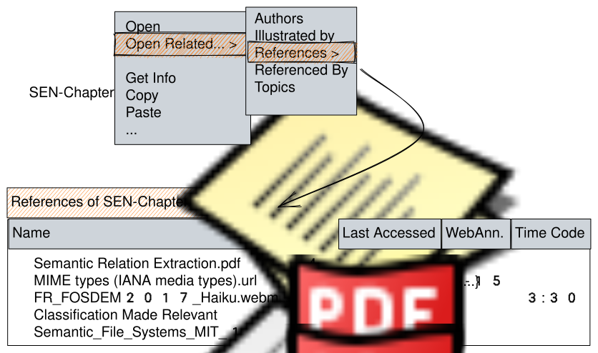
- Relation Browser
- For ternary relations, we need to extend this concept and add another level, i.e. through a folder inside the virtual folder, that holds all relation properties from the source entity to the 3rd entity involved in the relation.
  - e.g., for references from an annotation to a paper that references another author in several ways and on several pages, SEN would create a folder “ Relations to ” inside the virtual folder “ relations to ”.
  - this nested folder would then hold all references with label and page number as file attributes, shown in columns (without actual file types or targets, since the file (type) will always be the relation source, and the target is always the third entity involved), e.g.:
Label | Page
quotes | 2
references | 4
associates | 7
- [[Fig]].{14}.{13}.{This table illustrates a nested folder showing all outgoing links and properties of a ternary relation.}

Calendar
- using Event files and Relations for connecting events based on sequence and time (navigating between recurring events or a daily/weekly agenda)
- we can then build a simple “Today” view from a query for all Events on a given date, even filtered by tags or participating contacts, which are also files)
  - clicking on a “calendar” icon in the desk bar (application launcher and info panel) would open a Tracker window with all event files having an event date of today.
- 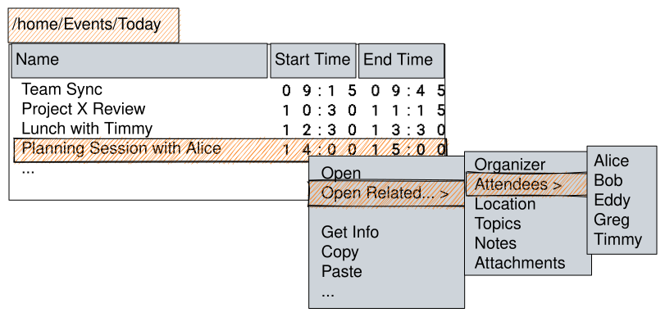
- Calendar Event Browser

E-Mail

Notes: UNO - a Concept for a Universal NOtebook
- Simple but Semantic
- also suitable for story writing: characters, locations and story arch as (self-)references
- Features and Use Cases - Authoring system (Relation Views for self-relations (structure, internal links to entities in the text) and external references)
- Prototype Concept: 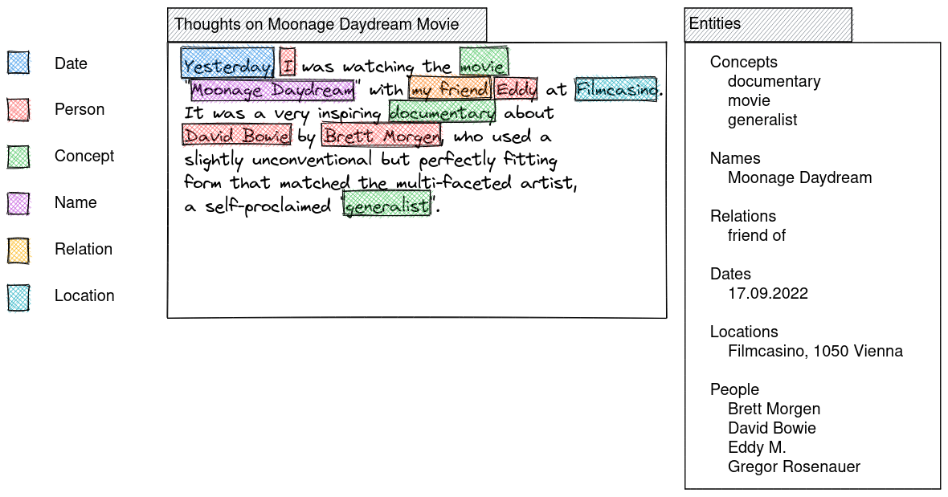
- as outlined above, all extracted entities can also be browsed by navigating the text file’s relations in the file browser: 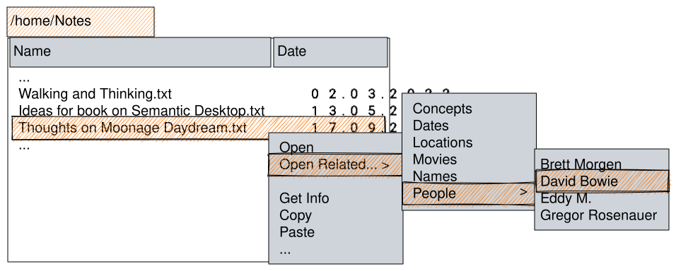
  - for ternary relations, as mentioned above, we need to extend this concept and add another level, i.e. a folder, to hold all relation properties to the 3rd entity involved in the relation:

Extending a Code Editor into an IDE
- adding semantic structuring and navigation using SEN
- self-relations for, e.g., methods and classes
- external relations for included files (C/C++) or referenced classes (Java imports)
- can be realised on top of existing application(s) using SEN API, or even (more as a showcase) using the SEN enabled file browser.
- example:
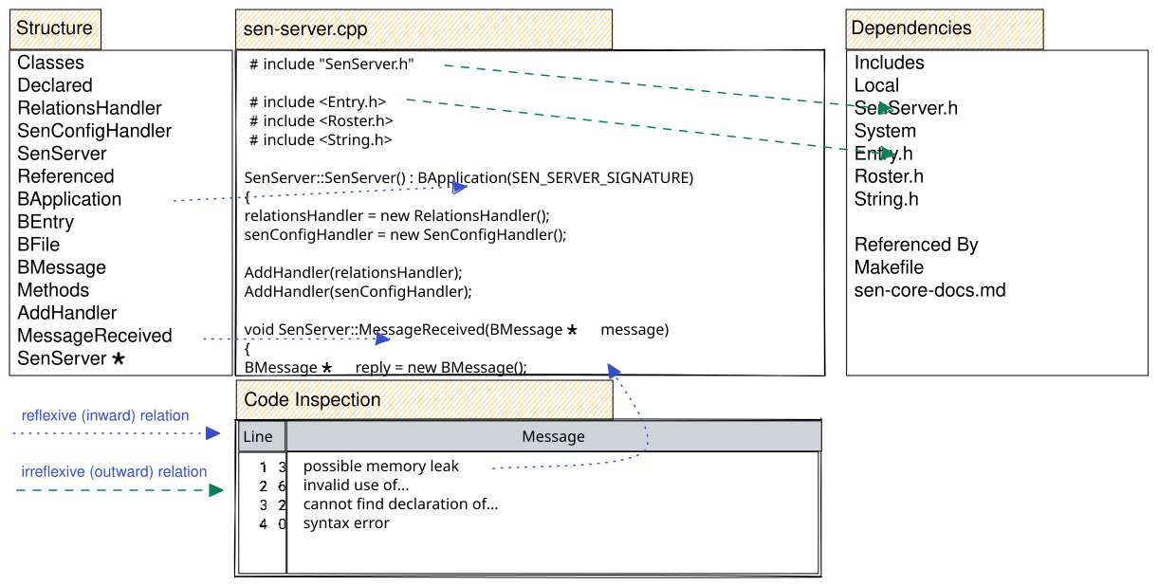
SEN-IDE

Outlook, Ongoing and Future Work
- Integrating Information Extraction and Document Analysis
- Building Dynamic Relations: lazily evaluated when user navigates them, used for expensive and volatile relations e.g. for “similar” files
- Rules and Inference of Relations and Attributes
- Further Desktop Extensions:
  - rich Tracker views, e.g. 2d-axis view for arranging items on a timeline, or by proximity etc.

References
- Access Co., Ltd. (n.d.). The Be Book—System Overview—The Application Kit. Retrieved September 28, 2022, from https://www.haiku-os.org/legacy-docs/bebook/TheApplicationKit_Scripting.html
- Alexander Obenauer. (2021, August 21). The Graph OS. The Lab Notes. https://alexanderobenauer.com/labnotes/014/
- Ames, A., Maltzahn, C., Bobb, N., Miller, E. L., Brandt, S. A., Neeman, A., Hiatt, A., & Tuteja, D. (2005). Richer File System Metadata Using Links and Attributes. 22nd IEEE / 13th NASA Goddard Conference on Mass Storage Systems and Technologies (MSST’05), 49–60. https://doi.org/10.1109/MSST.2005.28
- Berman, J. J. (2022). Classification made relevant how scientists build and use classifications and ontologies. Academic Press.
- Bushnell, T. (2015, March 8). Towards a New Strategy of OS Design, an architectural overview by Thomas Bushnell, BSG. https://www.gnu.org/software/hurd/hurd-paper.html#design
- Dan McCreary. (2022, April 7). Personal Knowledge Graphs. Towards Data Science. https://towardsdatascience.com/personal-knowledge-graphs-9a23a0b099af
- Gifford, D. K., Jouvelot, P., Sheldon, M. A., & O’Toole, J. W. (1991). Semantic file systems. Proceedings of the Thirteenth ACM Symposium on Operating Systems Principles - SOSP ’91, 16–25. https://doi.org/10.1145/121132.121138
- Google (Director). (2007, February 13). Haiku: The Operating System. https://www.youtube.com/watch?v=LxAQxGQB1A8
- Haiku, V. (2022, September 12). The Haiku Book: Messaging Foundations. https://www.haiku-os.org/docs/api/app_messaging.html
- Humdinger, B. (2009a). Attributes (Haiku User Guide). https://www.haiku-os.org/docs/userguide/en/attributes.html
- Humdinger, B. (2009b). Haiku Filetypes (Userguide). The Haiku Foundation. https://www.haiku-os.org/docs/userguide/en/filetypes.html
- Humdinger, B. (2019). Workshop: Filetypes, Attributes, Index and Queries. https://www.haiku-os.org/docs/userguide/en/workshop-filetypes+attributes.html
- Matuschak, A. (n.d.). Evergreen Notes. Andy’s Working Notes. https://notes.andymatuschak.org/z4SDCZQeRo4xFEQ8H4qrSqd68ucpgE6LU155C
- Melnikov, A. (2022). IANA Media Types. Internet Assigned Numbers Authority. https://www.iana.org/assignments/media-types/media-types.xhtml
- Revol, F. (n.d.). Haiku, a desktop you can still learn from. 19.
- Revol, F. (2017, February 7). Haiku, a desktop you can still learn from. https://archive.fosdem.org/2017/schedule/event/desktops_haiku_desktop_still_learn_from/attachments/slides/1826/export/events/attachments/desktops_haiku_desktop_still_learn_from/slides/1826/FR_FOSDEM2017_Haiku.pdf
- schema.org, V. (2022a, March 17). Data Model—Schema.org. https://schema.org/docs/datamodel.html
- schema.org, V. (2022b, March 17). Schema.org—Schemas—Schema.org. https://schema.org/docs/schemas.html
- Silverston, L. (2020, November 18). Zen and the Art of Data Maintenance: Data ’Mine’ing and Universal Data Semantics. The Data Administration Newsletter. https://tdan.com/zen-and-the-art-of-data-maintenance-data-mineing-and-universal-data-semantics/27543
- Sporny, M. (2020, July 16). JSON-LD 1.1. https://www.w3.org/TR/json-ld/
- Telburt, J. (2022, February 16). Data Speaks for Itself: Data Littering. The Data Administration Newsletter. https://tdan.com/data-speaks-for-itself-data-littering/29122
- Various. (2022). MIME types (IANA media types). Mozilla Foundation. https://developer.mozilla.org/en-US/docs/Web/HTTP/Basics_of_HTTP/MIME_types
- Vef, M.-A., Steiner, R., Salkhordeh, R., Steinkamp, J., Vennetier, F., Smigielski, J.-F., & Brinkmann, A. (2020). DelveFS - An Event-Driven Semantic File System for Object Stores. 2020 IEEE International Conference on Cluster Computing (CLUSTER), 35–46. https://doi.org/10.1109/CLUSTER49012.2020.00014
- W3C. (n.d.). WebAnnotation Home. WebAnnotation: Retrieved September 21, 2022, from http://webannotation.org/

